Reporting Types
There are a variety of reports available for your use in Greater Giving. Reports can be found in several different report menus, depending on the grid view used to generate the reports. You can find all available reports by selecting Project> Reports, or by looking under the reports section and clicking on “all reports.” You can also find specific reports by clicking the Report button within different Grid Views.

In the Project menu, click Project Reports. |  | Summary Reports include Sponsorship
SUM-07 | Summary - Total Admission and Package Sales | Overall Revenue by Stream
SUM-03 | Summary – Packages | Break down of Silent and Live auction totals
SUM-09 | Summary - Sales totals by group | Totals by table group
SUM-13 | Summary - Sales totals by pkg. sorted by amount | Top auction items
SUM-14 | Summary - Sales totals by bidder sorted by amount | Top donors and bidders
SUM-18 | Summary - Sales totals by table | Totals by table number (also includes amount still due)
SUM-19 | Summary - Sales totals by package sorted by amount by section | Total given for each section (ex: COR, Custom Sponsorships, OYH…)
In the View menu, click Packages. Click the Report button.
PKG-03 | Sales listing by package with buyers | Includes buyers contact information
PKG-04 | Sales by package - bid numbers only (no names or amounts)
PKG-05 | Sales totals by package | Auction sales yield (includes item value, sale price and percentage of return)
PKG-12 | Packages with cost and profit
In the View menu, click Supporters.
BID-03 | Sales listing by bidder | Sales and payments listed by bidder
BID-04 | Sales listing by bid number without bidder names or amount
BID-15 | Admittance sales (not based on current selection)
DON-04 | Sales listing by donor
STF-02 | Sales listing by solicitor
In the View menu, click Table Groups. Click the Report button.
GRP-02 | Sales listing by group
In the View menu, click Payments. Click the Report button.
PAY-01 | Payment transaction
PAY-02 | Payment totals by type
In the View menu, click Sales. Click the Report button.
SLS-01 | Sales transactions

Exports

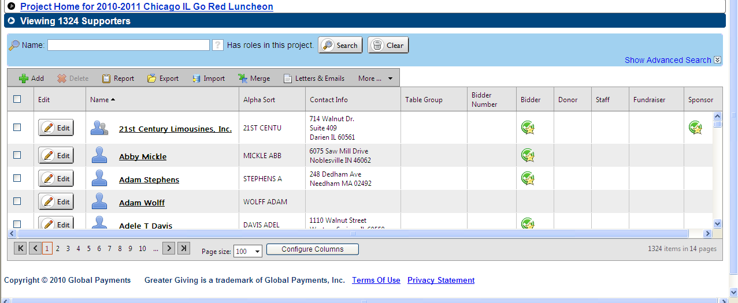

Advanced Exports under Supporter Record:  click export, then advanced export radio button. |  | Advanced export includes:
Sales for Accounting | Select sales for accounting from drop down list | All purchases by individuals with contact information
Staff and Their Committees | Select from drop down and leave export specific options blank | Committee listing with individual contact information
Supporter Email List | Select from “supporter email list” from drop down | Support emails that are entered in Greater Giving

Advanced Search

In the supporter, sales and payments, items and packages sections you have the option to do an advanced search. The advance search varies based on which section you are in.

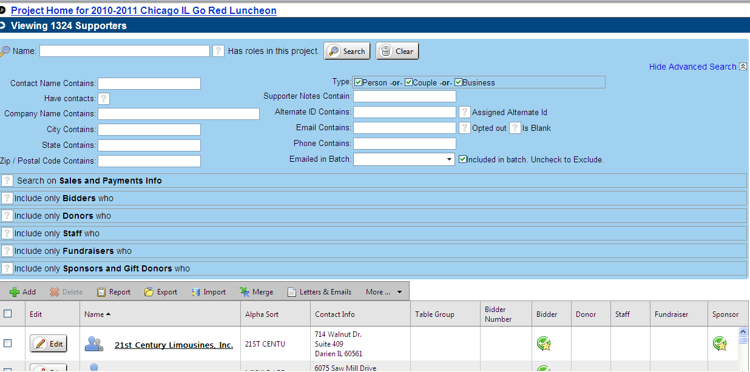

Helpful queries:

Supporter Record advanced search: |  | Advanced search includes:
Fundraisers | By checking fundraisers you can query for all Join Me fundraisers | All information under the supporter record about those fundraisers
Sponsor and Gift Donors | You can query by type, solicitation status, amount ask date… | Committee listing with individual contact information
Bidders | You can query for people seated at specific tables, how many seats they used, by bidder number… | All information under the supporter record about those bidders
Payment Record advanced search: |  | Advanced search includes:
Payment Type | Search by payment type (online credit card information can be helpful) | *only includes payment information, NOT contact information

